Portfolio section | What to write | Evidence to link
Introduction | Our team developed Cyber Run, an interactive educational game designed to teach digital safety and phishing awareness to university students (ages 18–25). Set in a futuristic "Cyber City," the game helps users identify live threats and scams. My individual role focused on Project Planning, Presentation Design, and Report Documentation. | 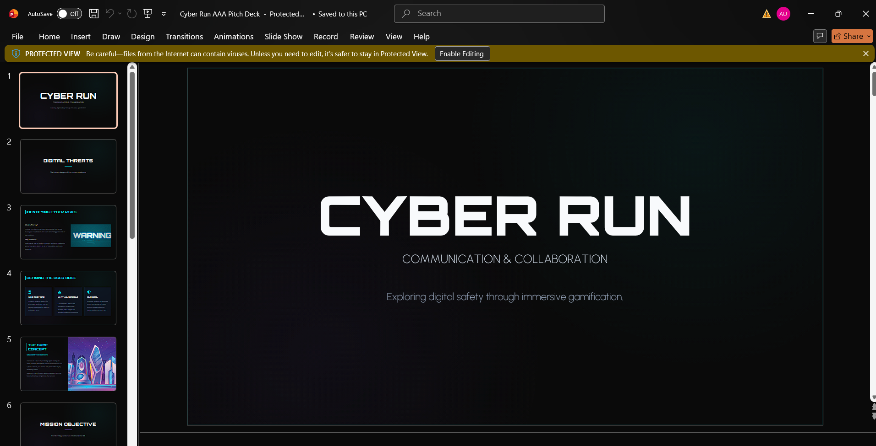
Project planning and teamwork | My primary contributions were focused on communication and project management. Specifically, I:  • Designed and structured the Cyber Run Pitch Deck slides (including user demographics, accessibility pillars, and gameplay flows).  • Monitored the project action log and team deadlines.  • Co-wrote, consolidated, and edited the final project report. | 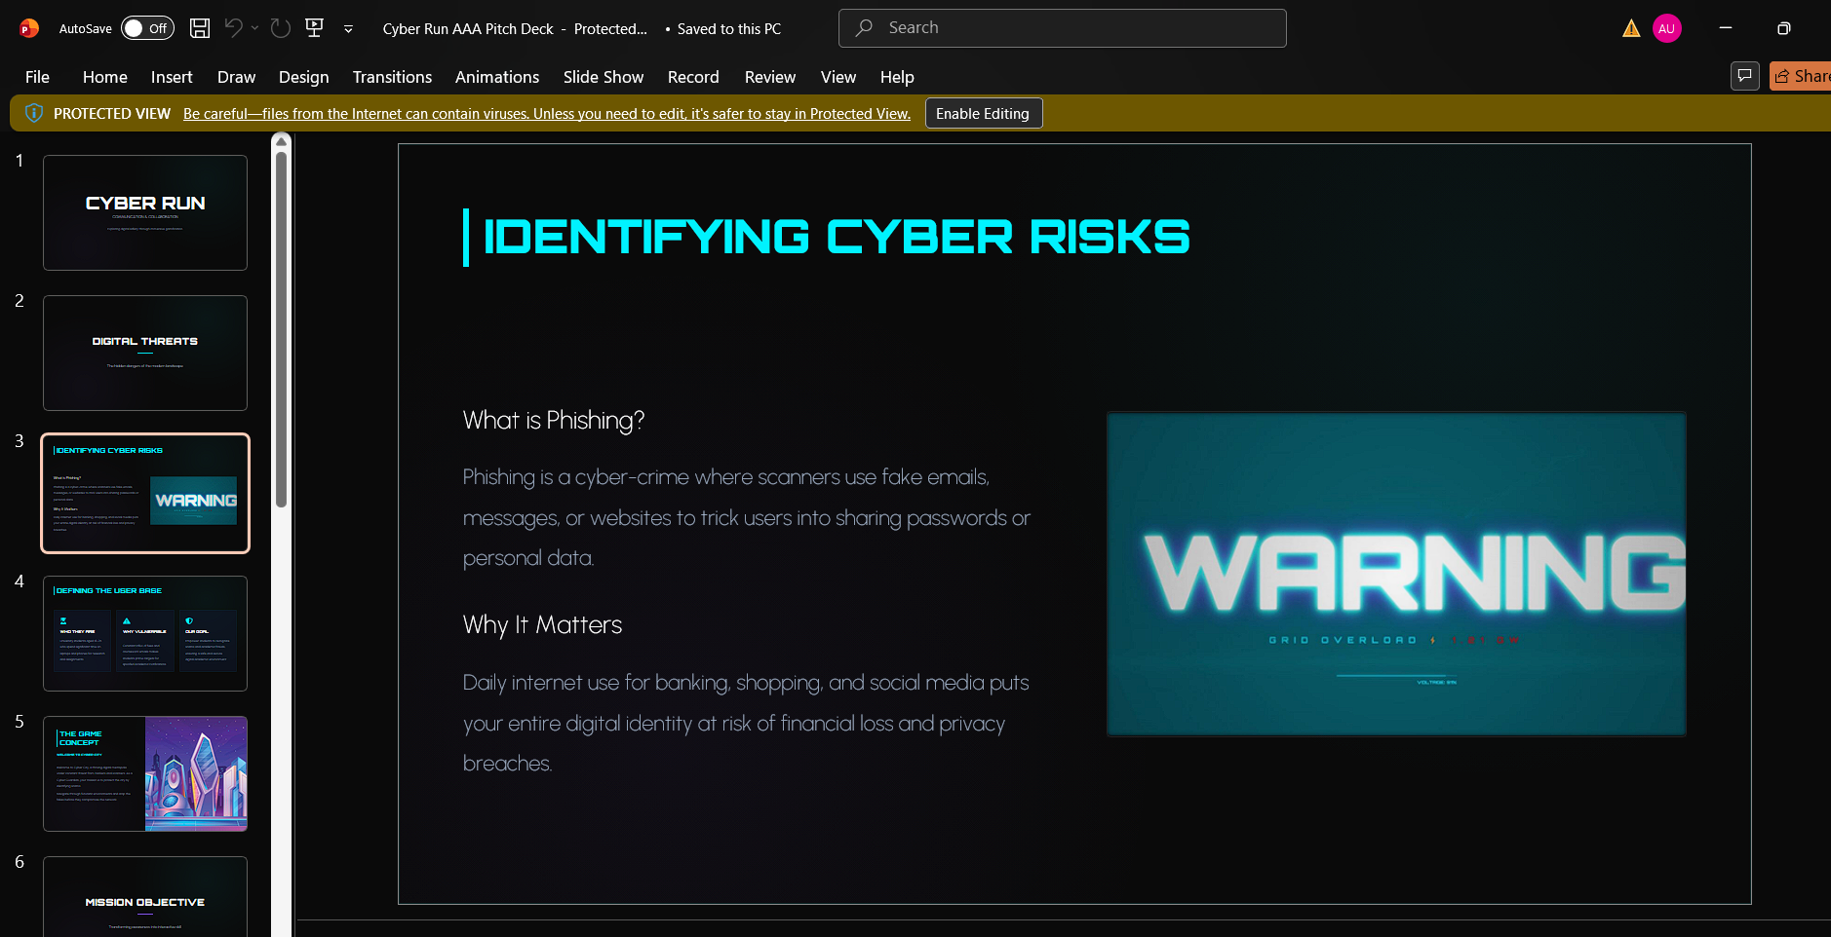
Personal contribution | The Cyber Run prototype evolved from a basic narrative storyboard into an interactive gameplay showcase with screen blueprints. I documented this progression in the pitch deck, highlighting the transition into clear "Real vs. Scam" feedback loops, the user tutorial system, and core accessibility features like screen-reader support.
Prototype development | Our team communicated effectively via group chats and shared cloud drives. We faced minor friction aligning the technical side of the presentation with the academic tone of the report. We resolved this through constructive peer feedback, allowing us to simplify the presentation layouts and refine our shared data. | Peer feedback forms, meeting minutes, document comments
Communication and collaboration reflection | This project improved my skills in project management, technical writing, and asset communication. I learned how to synthesize complex educational gameplay ideas into a concise pitch deck for stakeholders. In the future, I plan to master agile planning methodologies to coordinate multidisciplinary teams better. | 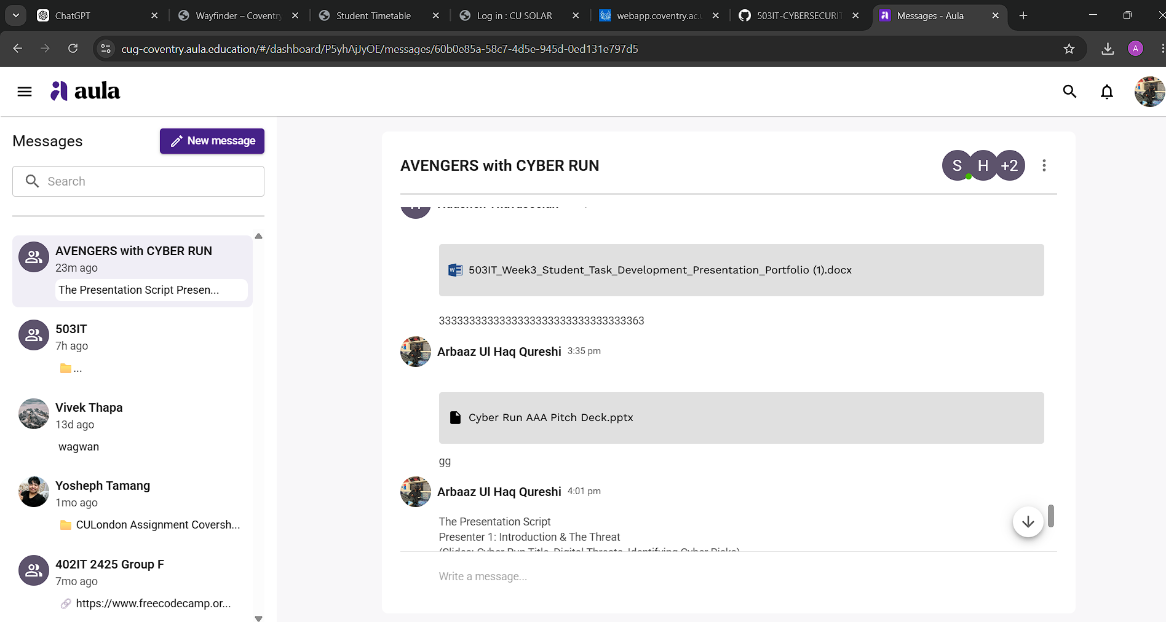
Professional development | AI tools were used solely to brainstorm presentation layout ideas, structure meeting schedules, and refine the grammatical flow of the written report. All core game concepts, target audience analysis, and presentation assets were authentically created by our team. | AI use log, prompt history map
Appendices | All supporting evidence referenced throughout this report has been compiled and indexed in the final section of this document to verify individual contributions and track development logs. | Appendix evidence map

